

**University of Pittsburgh**

**INFSCI 2710**

**Database Management**

**2016-2017 Fall**

Jianyu Shen

Xinying Sun

Yu Qiu

**INTRODUCTION:**

Our system is designed to facilitate, conduct, and track the sale of items within on-line stores, could automate the functions of a sales company with E-Commerce.  Users in the system include customers, sellers, and administrators. The mainly user of customers have access to their profile, past and current transactions, and information on products. Browsing of products is particularly flexible in that customers are able to brows based on category of product, top rated products, or by searching after typing in a string of text. Information on each product made available includes name, description, inventory amount, price, brand, as well as an image of product. Sellers have access to much of the data in the database. These data include information pertaining to customers’ potential businesses, transaction history, products, and the salesperson, store, and regional company data. Lastly, administrators have same access to the database and has access to customer feedback to make any revisions if necessary.

**ASSUMPTIONS:**

When transactions take place, our system records all necessary transactional information and makes updates to product inventory and order tables.

The system also can perform queries to display

[1] Information Browsing: administrator and seller can get detailed information on product, user and order by typing in key word.

[2] Data Aggregation: In this part we have several interesting aggregate queries.

• Get the top category and user of the system: The system can generate most popular product, product category, and most active user with this query.

• Show sales volume in different regions: The administrator can compare the sales according to different regions.

• Show product sales according to date: This gives an overview of the daily sales, which will help make the decision of increasing inventory.

• Show profits made by each salesman: The function gives output about the profits of each salesman and helps store evaluate each salesman.

• Get salesmen who made max and min profits: It will show the most promising salesman and the one with worst performance.

• Find the business buying given products the most: The last query will get the business who buying the most amount of given product by administrator.

Error exception throw

If errors are made by users while navigating the various functionalities of our system, exceptions are handled and error messages are reported to users so that they may attempt to remedy any mistakes they have made.

The system assumes that all customer data must be entered in correct format to make a customer profile. The system also assumes that orders cannot be made for items with insufficient product inventory (i.e., transactions cannot be made for sold-out items). Every transaction that takes place is referenced to one and only one salesperson, whose sale is referenced to one and only one associated store and region.

ER diagram

People who are using this website have their unique usernames and passwords.

Each salesperson can only work in one store. And each store must have a store manager. Each store must locate in one of the regions that in the system. And each region must have a region manager.

A region manager can manage more than one regions. And a store manager can manage more than one stores.

A customer must be either a business customer or a home customer.

**DESCRIPTION OF THE E-R DIAGRAM:**

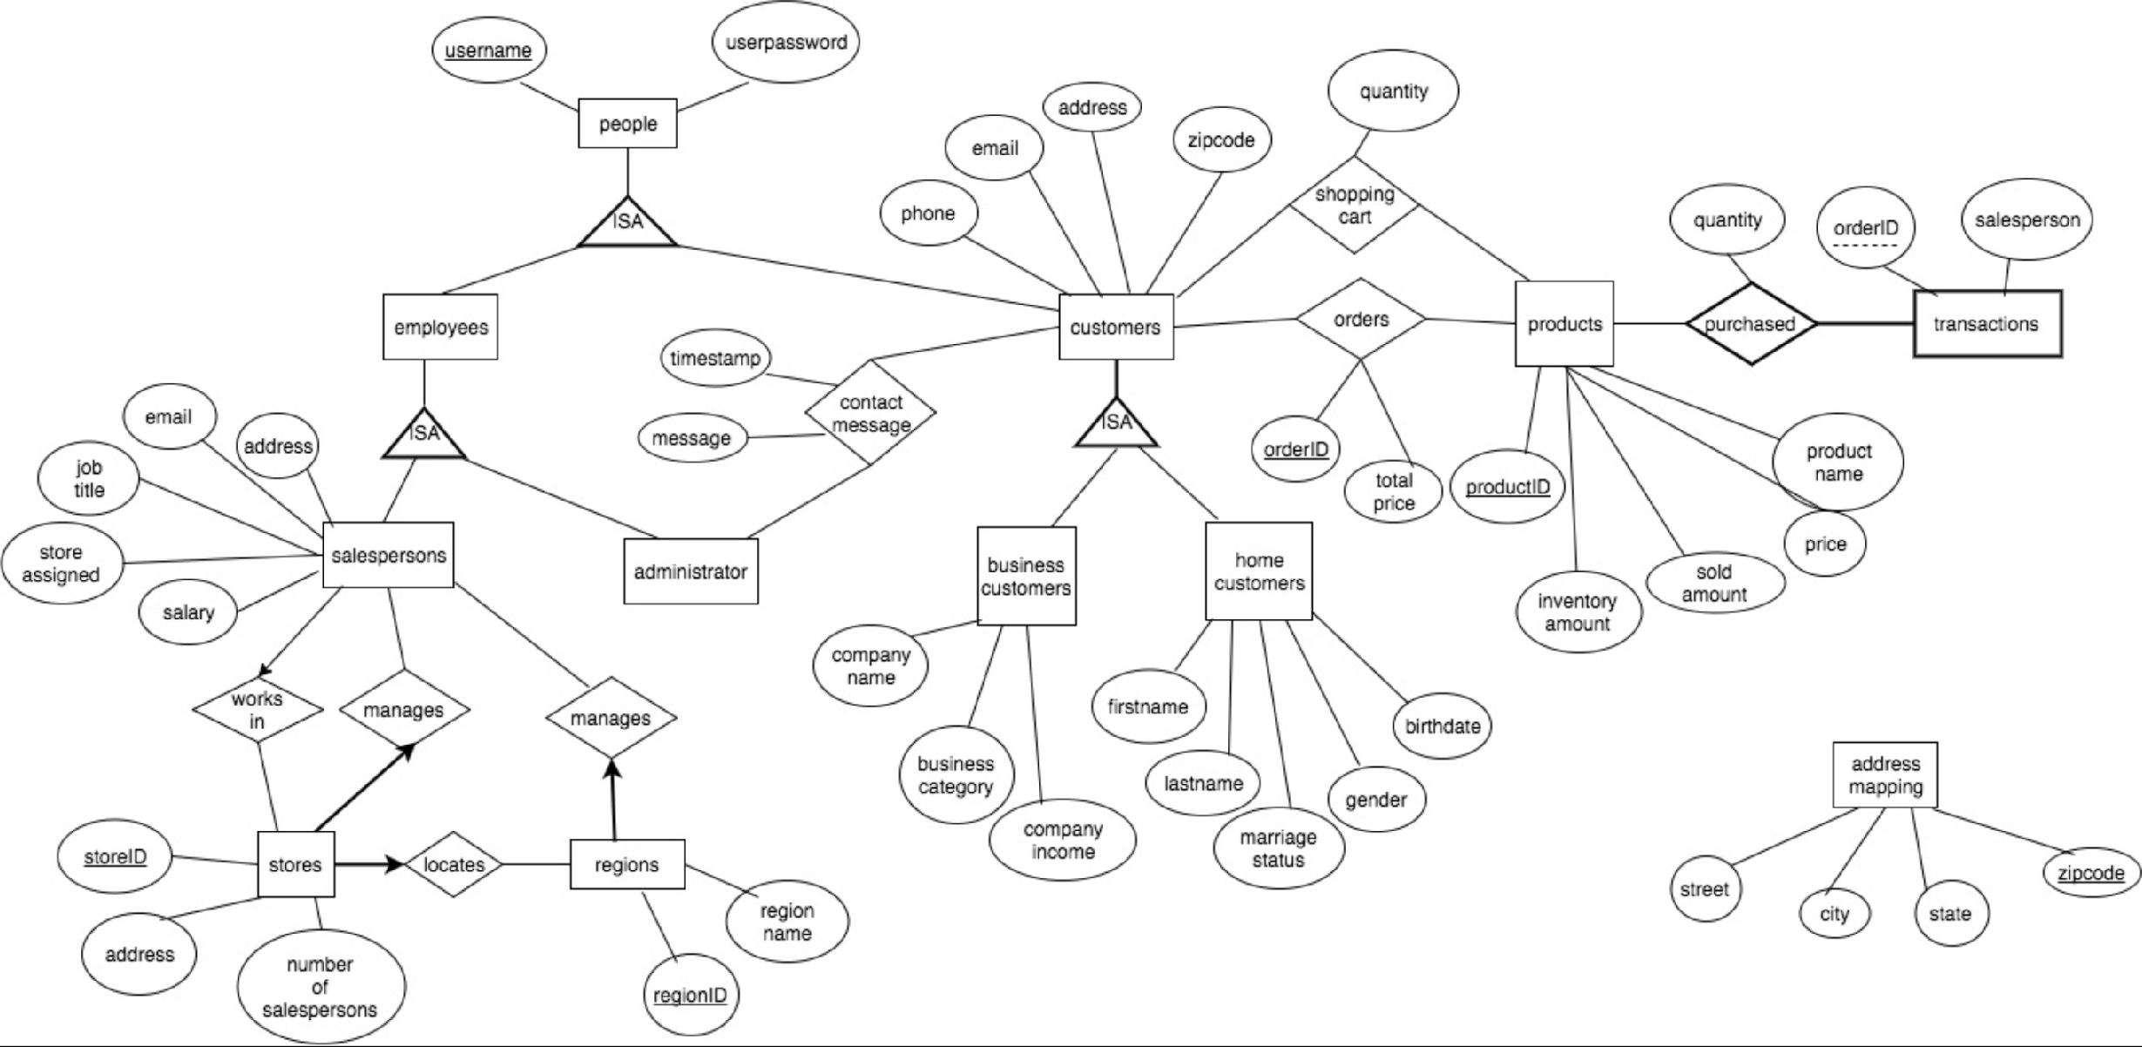

This part features an Entity-Relationship Diagram detailing the composition of our database. All the entities are list as below:

[1] Customers

[2] BusinessCustomer

[3] HomeCustomer

[4] Products

[5] administrator

[6] Region

[7] store

[8] Salesperson

[9] orders

[10] Transections

[11] shoppingcart

[12] addressmapping

**DESCRIPTION OF FRONT-END TO BACK END DESIGN:**

The entire front-end is designed using JSP and HTML. Java servlets are used to connect to the back-end SQL database. We have used NetBeans GlassFish Server 4.1.1 for running the web page and XAMPP for running the SQL database. A lot of exceptions are handled using try and catch functions in the front end.

**Homepage:**

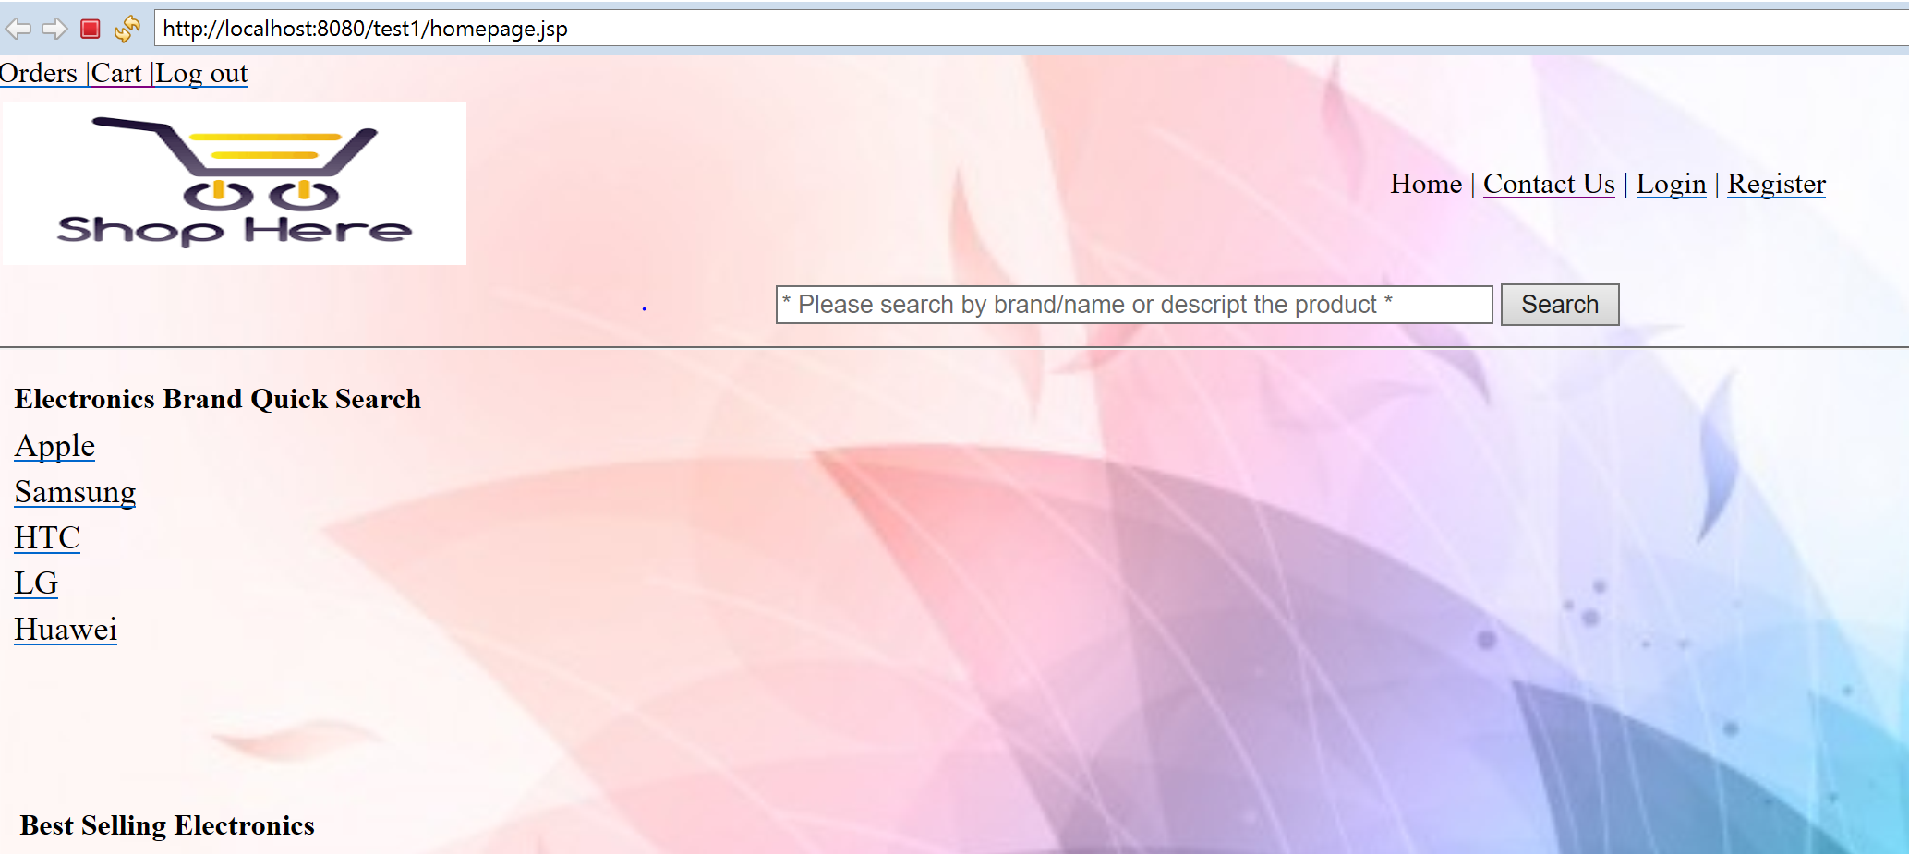

The homepage serves as the main page for users who are trying to navigate to all other web pages. It displays a list of products which has high rating in each category. It also has a search function and browse through brand/name or description’ function.

**Login web pages:**

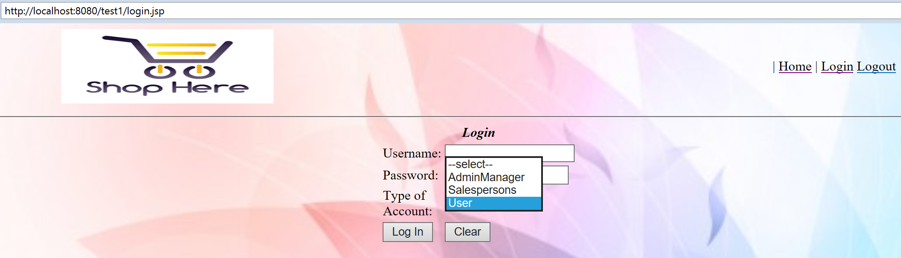

The login web page allows users to enter their login credentials and the type of account, a specific user is trying to login. Once the user logs in, data are compared with those in the SQL database and the user is either successfully logged in, or is notified for entering wrong credentials, otherwise the error exception will be display. This login web page serves as the common page for administrators, users and sellers.



If the login information can totally match to database, the hello page will appear:



While the information is not mapping, the error information will be throw out.

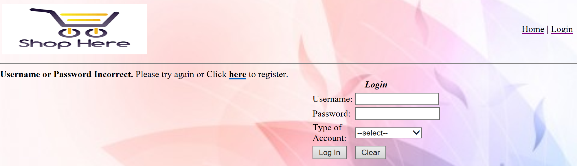

From the two screen shots above, it can be seen that users are either logged in, or notified based on their login credentials.

**Registration web pages:**

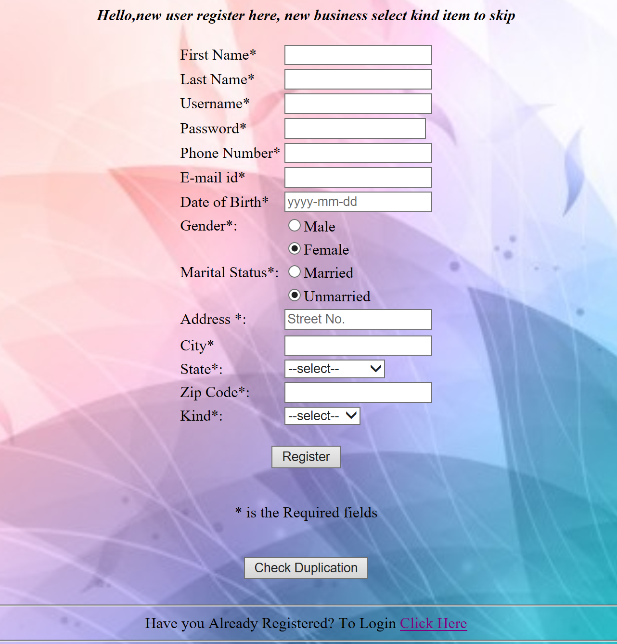

The registration web page allows new users to enter their credentials and create a login username and password in order to buy products. Users do have the option to select their type of business. If they want to register as a business user, they have a separate business registration web page to enter their business details. Normal home users are routed to the homepage directly.

The web page shown below, is the registration web page for business users. Once users fill this form, they are routed to the homepage.

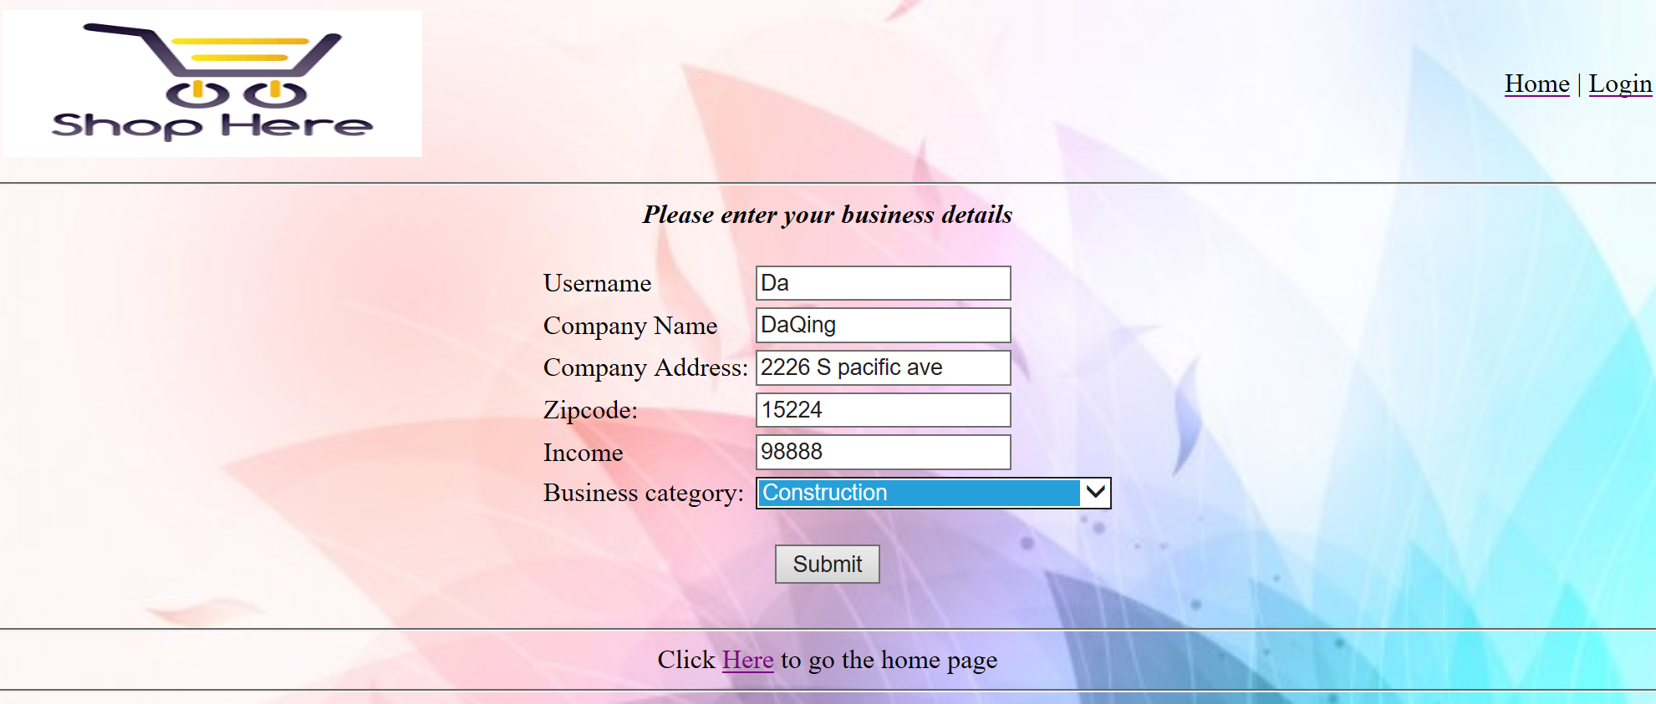

If the register information encounter invalid input, the error page will be throw and user will be required be double check information.

After the register process finished, the successful page will be run out:



**Products web Page:**

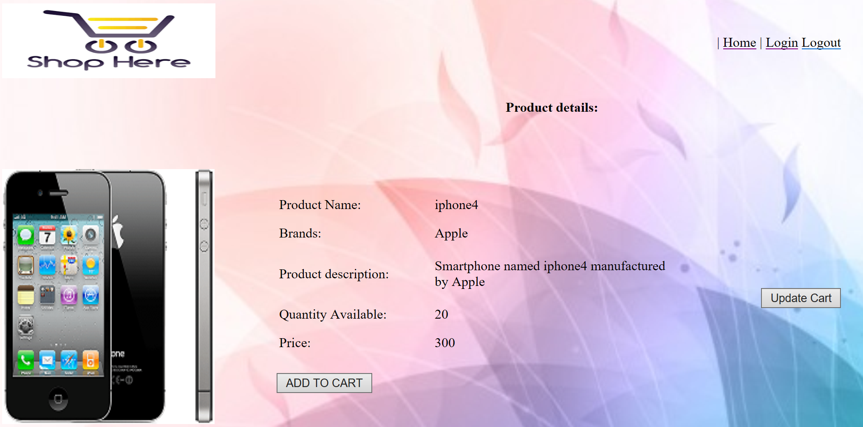

The products web page displays all details about the product. The quantity entered is compared with the inventory amount and a message is displayed to the user.

If the quantity entered is more than the available amount, the user is notified with a message stating that required quantity is not available.

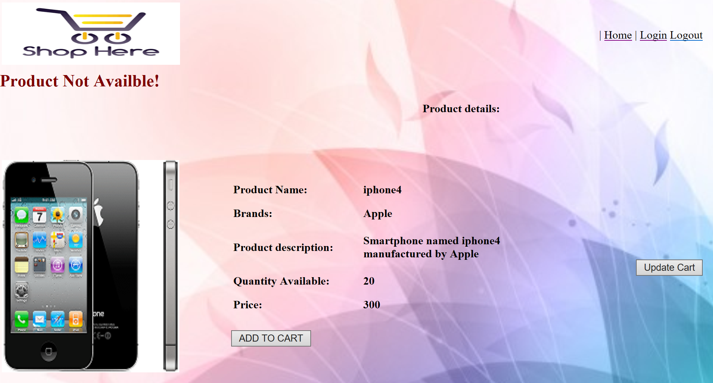

**Online shopping cart:**

If users want to buy products, they have to add products to their online cart. The below shown screenshot displays the products which are currently available in the cart.

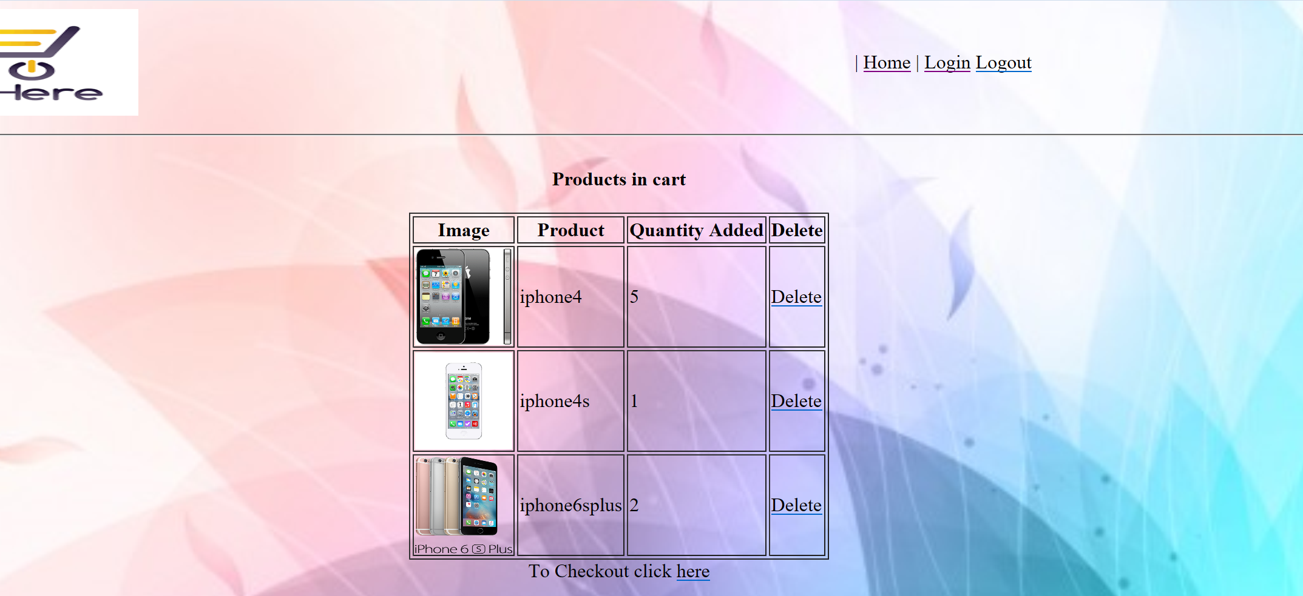

Users are also given an option to delete the products from the online cart, if they do not want to buy the product.

**Search web page:**

Users can search for products using the search web page and the result is shown by the below screenshot.

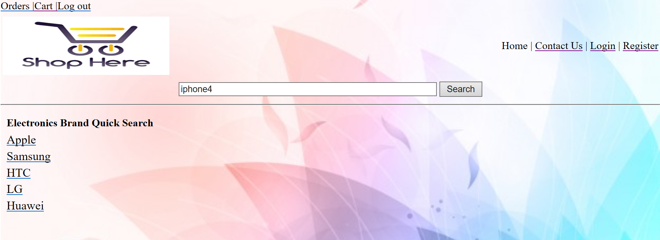



**Buy web page:**

Users can check out the products which are in the cart.

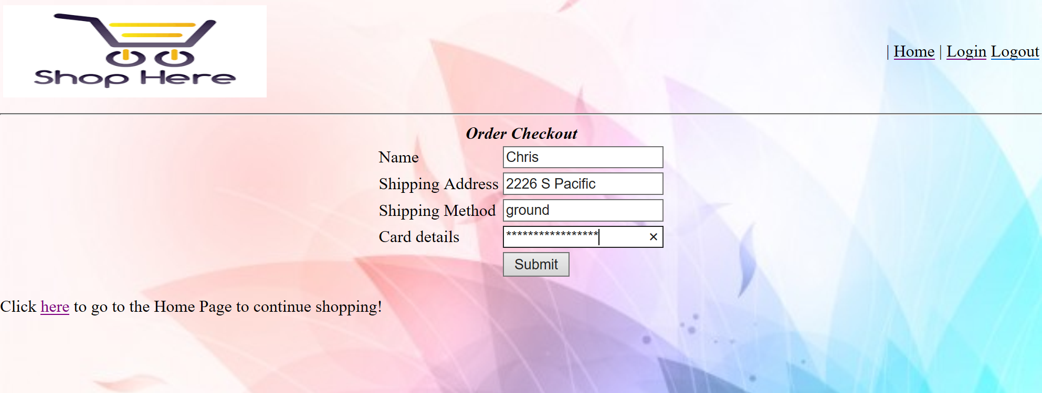

Once, all the required credentials are entered, the products are successfully ordered and are delivered to the provided shipping address.

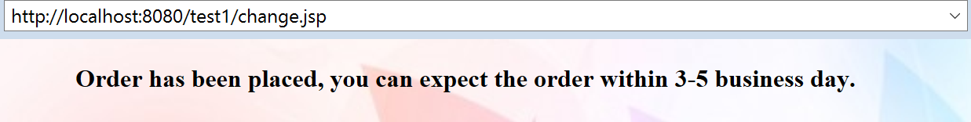

**Seller web page:**

Sellers can select the brand and the result is the list of all available products in that category.



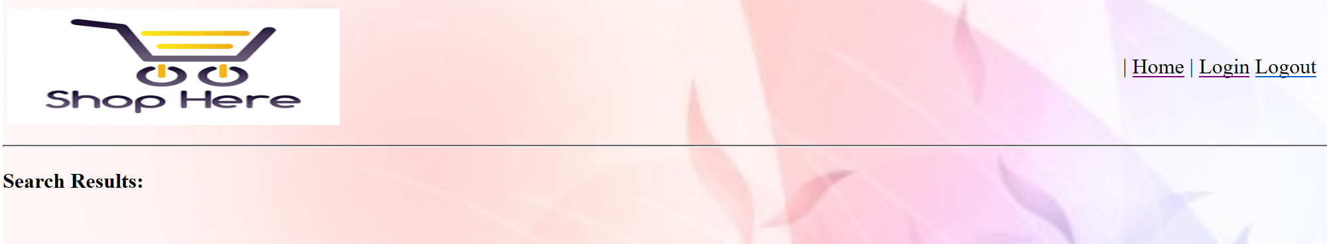

After selecting the product, sellers will be able to see the region data of products.

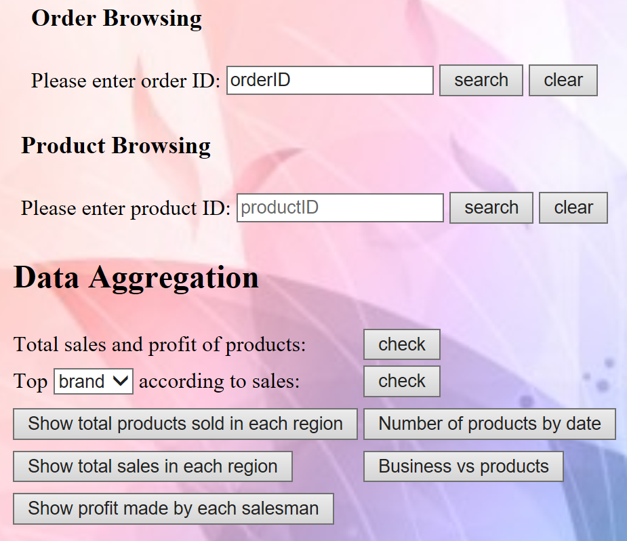

**Erroneous cases:**

All erroneous cases are handled in a good way and attached are the screenshots of the cases.

Trying to add a product before logging in:



Wrong username and password credentials:

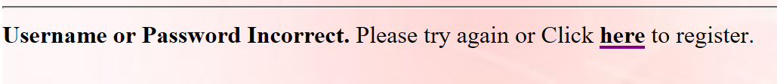

Required quantity is larger than inventory amount:



We tested the project using large amount of data sets by inserting values into the respective tables and writing SQL queries to fetch the data. Transactions were tested using different cases and handled the cases which violated our stated assumptions. All other functionalities were tested from the perspective of user, seller and administrator.

**Contact us web page:**

If any user faces any kind of difficulty, they are allowed to send a message to the administrators using the contact us web page.

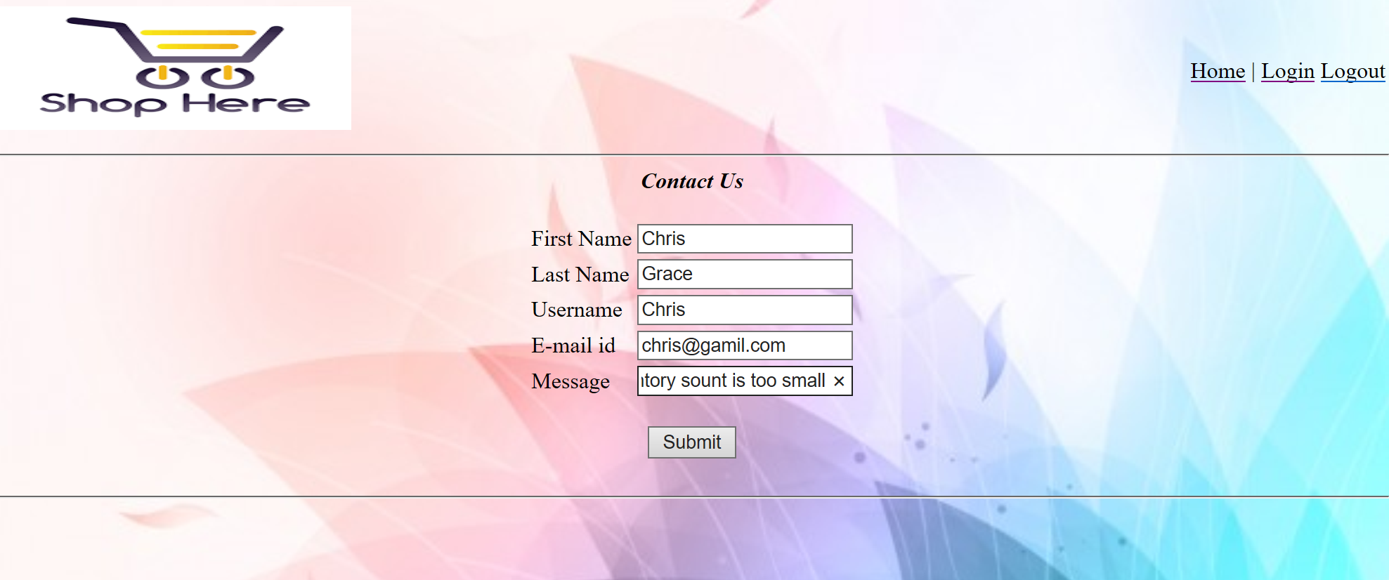

**System limitation:**

[1] Seller function didn’t expand all-sided. The function of chat with customers and communicate feedback with administrator didn’t be implemented totally.

[2] Function of administrator can be extended like administer total users and sellers, have access to expel venom customers and sellers. Rating best sellers in terms of selling amount, ect.

**APPENDIX:**

CREATE TABLE Customers(

username varchar(20) NOT NULL,

userpassword varchar(30),

customertype varchar(20),

PRIMARY KEY(username));

CREATE TABLE BusinessCustomer(

username varchar(20) NOT NULL,

company_name varchar(30),

phone varchar(20),

email varchar(30),

address varchar(30),

zipcode varchar(10),

company_income REAL,

business_category varchar(20),PRIMARY KEY(username));

CREATE TABLE HomeCustomer(

username VARCHAR(20) NOT NULL,

firstname VARCHAR(10),

lastname VARCHAR(10),

marriage_status VARCHAR(20),

gender VARCHAR(10),

birth_date DATE,

address VARCHAR(20),

zipcode VARCHAR(10),

phone varchar(20),

email varchar(25),

PRIMARY KEY(username));

CREATE TABLE Products(

productID varchar(10) NOT NULL,

product_name varchar(10),

inventory_amount int,

sold_amount int,

price REAL,

brand varchar(20),

product_description varchar(100),

PRIMARY KEY(productID));

CREATE TABLE administrator(

admin_name varchar(10) NOT NULL,

admin_password varchar(30),

PRIMARY KEY(admin_name));

CREATE TABLE Region(

regionID varchar(10) NOT NULL,

region_name varchar(20),

region_manager varchar(10),

PRIMARY KEY(regionID));

CREATE TABLE store(

storeID varchar(10),

address varchar(20),

manager varchar(10),

num_of_salespersons int,

region varchar(10),

PRIMARY KEY (storeID),

FOREIGN KEY(region) REFERENCES Region(regionID));

CREATE TABLE Salesperson(

sales_username varchar(10) NOT NULL,

sales_password varchar(30),

sales_name varchar(15),

address varchar(20),

email varchar(20),

job_title varchar(15),

store_assigned varchar(10),

salary int,

PRIMARY KEY(sales_username),

FOREIGN KEY(store_assigned) REFERENCES Store(storeID)

ON UPDATE CASCADE

ON DELETE SET NULL);

CREATE TABLE orders(

orderID varchar(10),

customerID varchar(20),

Total_price real,

PRIMARY KEY(orderID),

FOREIGN KEY(customerID) REFERENCES

Customers(username));

CREATE TABLE Transactions(

orderID varchar(10) NOT NULL,

productID varchar(10),

salesperson varchar(10),

quantity int,

customer varchar(20),

PRIMARY KEY(orderID, productID),

FOREIGN KEY(orderID) REFERENCES Orders(orderID)

ON DELETE CASCADE,

FOREIGN KEY(productID) REFERENCES Products(productID)

ON UPDATE CASCADE,

FOREIGN KEY(salesperson) REFERENCES

Salesperson(sales_username)

ON DELETE SET NULL,

FOREIGN KEY(customer) REFERENCES Customers(username)

);

CREATE TABLE shoppingcart(

productID varchar(10) NOT NULL,

product_name varchar(10),

customerID varchar(20),

quantity int,

price real,

PRIMARY KEY(customerID,productID),

FOREIGN KEY(customerID) REFERENCES customers(username),

FOREIGN KEY(productID) REFERENCES products(productID)

);

CREATE TABLE addressmapping(

Zipcode varchar(20),

Street varchar(20),

City varchar(20),

State varchar(20),

PRIMARY KEY(zipcode));